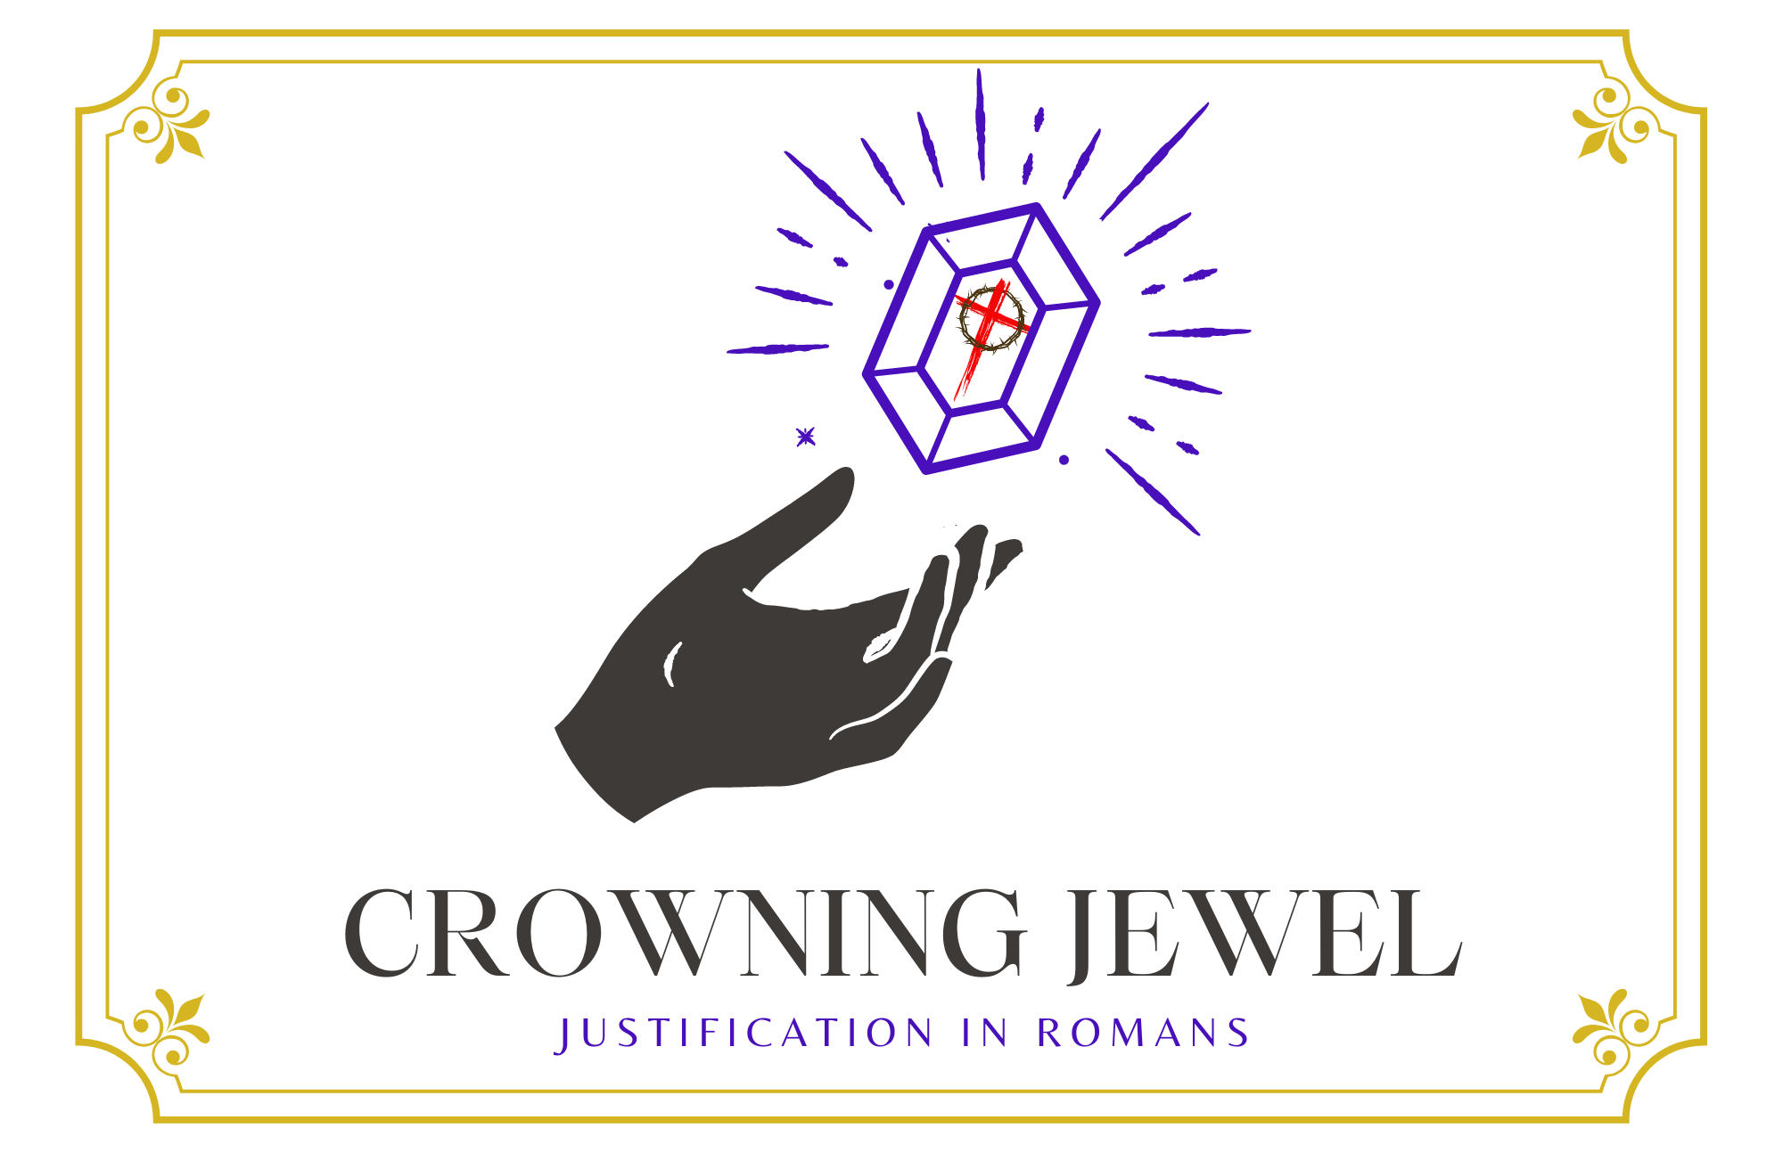

5th Sunday in Lent

CHRIST LUTHERAN CHURCH | Lodi, California
March 17, 2024

WELCOME TO WORSHIP
Welcome to Christ Lutheran Church. We pray that your soul will be strengthened by the good news about God’s grace, love, and forgiveness given to us. If you would like to learn more about our church, please speak with our pastor or one of our members after the service.
- Bathrooms are located in the fellowship hall. A changing table is located in the women’s bathroom.
WORSHIP THEME
Christ is our righteousness. Through faith in him, we stand before God with full confidence and without fear. We have no need to worry about where we stand with God because we know that Christ has died and risen to remove our sins and grant us his righteousness.
One theologian has called justification the crowning jewel of Christian doctrine. Like a finely cut gemstone, this teaching of the Bible has many facets, and every time we examine it from a different angle, new truths and fresh insights come into view like light reflecting from its face. During the season of Lent, we will examine some of the various aspects of what Christ accomplished for us.
The Service of the Word and Sacrament
The high and holy worship of God is faith in Jesus Christ. Such faith is created and sustained by God’s service to us (the German, “Gottesdienst,” “God/Divine Service).
In the Divine Service, the Lord comes to us in His Word and Sacrament to bless and enliven us with His gifts. The Service is not something we do for God, but His service to us received in faith. The liturgy is God’s work. He gives, we receive.
HYMN Jesus My Great High Priest| CW 359
INVOCATION
From God’s Word we know that wherever God puts His name, there He is to bless. Today, in honor of Saint Patrick, we use portions of Saint Patrick’s Breastplate in our service. This prayer of protection begins by invoking the name of the Triune God, then asks for God’s guidance, strength, and protection through the whole day.
In addition to the Invocation, portions of the Breastplate will be used during the Kyrie and the closing prayer.
M: In the name of the Father, and of the Son, ✙ and of the Holy Spirit.
C: We arise today through the mighty strength of the Trinity:
M: Through belief in the Threeness and confession of the Oneness; the Creator of creation.
C: Amen
CONFESSION
M: God invites us to come into his presence and worship him with humble and penitent hearts. Therefore, let us acknowledge our sinfulness and ask him to forgive us.
C: Holy and merciful Father, I confess that I am by nature sinful, and that I have disobeyed you in my thoughts, words, and actions. I have done what is evil and failed to do what is good. For this I deserve your punishment both now and in eternity. But I am truly sorry for my sins, and trusting in my Savior Jesus Christ, I pray: Lord, have mercy on me, a sinner.

absolution
M: God, our heavenly Father, has been merciful to us and has given his only Son to be the atoning sacrifice for our sins. Therefore, as a called servant of Christ and by his authority, I forgive you all your sins in the name of the Father and of the Son ✙ and of the Holy Spirit.
C: Amen
LORD, HAVE MERCY - Kyrie
M: May God’s strength pilot us, his might uphold us, his wisdom guide us from snares of devils, from temptation of vices, and from everyone who wishes ill whether far or near.
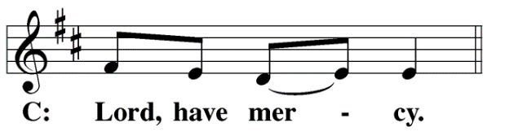

M: May God’s eye be upon us, his ear hear us, and his word speak for us against every threat to body and soul: the words of false prophets, the laws of heretics, and the corruptions in this world.
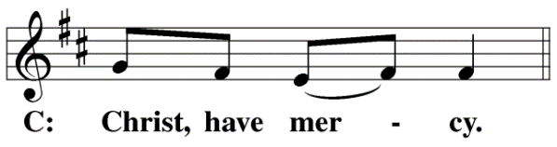
M: May God sustain us in the strength of confession: of Christ’s birth and his baptism; of his crucifixion and burial; of his resurrection and ascension; of his descent for the judgment of doom.
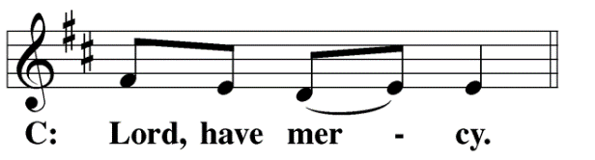
M: May the Holy Spirit sustain us in faith: in the prayers and preaching of His Apostles and Prophets, in our baptism, in the hope of resurrection, in righteous deeds, and in the holy food of His table.
M: May God’s angels attend us, his hand guard us, his shield protect us this day and always.
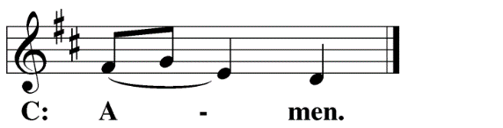

The Service of the Word
Having just received absolution for their sins, believers now gather around the Word of God to find encouragement and peace for their lives on earth.
PRAYER OF THE DAY
M: Let us pray.
Eternal God and Father, help us to remember Jesus, who obeyed your will and bore the cross for our salvation that through his anguish, pain, and death we may receive forgiveness of sins and inherit eternal life; through your Son, Jesus Christ our Lord, who lives and reigns with you and the Holy Spirit, one God, now and forever.
C: Amen
FIRST LESSON Jeremiah 31:31–34
The Lord will make a new covenant with his people: the covenant of forgiveness.
“The days are coming,” declares the Lord,
“when I will make a new covenant
with the people of Israel
and with the people of Judah.
It will not be like the covenant
I made with their ancestors
when I took them by the hand
to lead them out of Egypt,
because they broke my covenant,
though I was a husband to them,” declares the Lord.
“This is the covenant I will make with the people of Israel
after that time,” declares the Lord.
“I will put my law in their minds
and write it on their hearts.
I will be their God, and they will be my people.
No longer will they teach their neighbor,
or say to one another, ‘Know the Lord,’
because they will all know me,
from the least of them to the greatest,”
declares the Lord.
“For I will forgive their wickedness
and will remember their sins no more.”
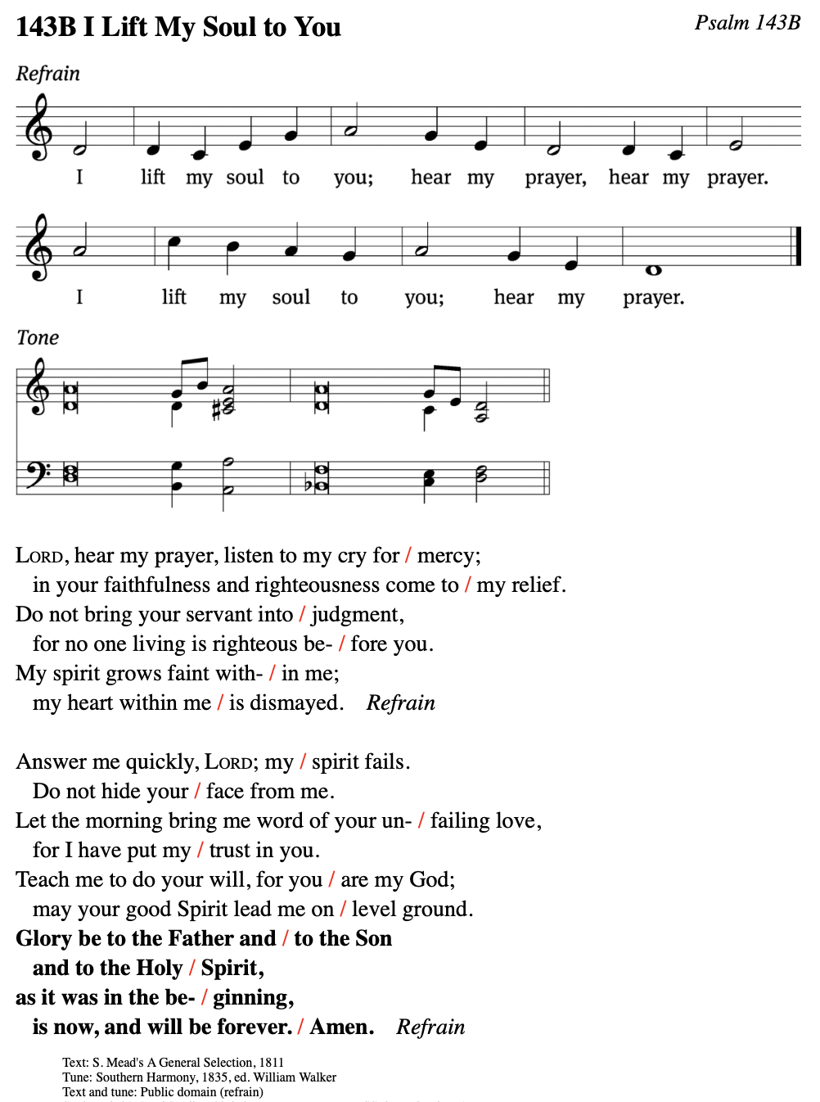
PSALM Psalm 143b
SECOND LESSON Romans 3:21–26
In the new covenant, God’s people are not made righteous by their own works; rather, we become righteous through faith in Christ.
But now apart from the law the righteousness of God has been made known, to which the Law and the Prophets testify. This righteousness is given through faith in Jesus Christ to all who believe. There is no difference between Jew and Gentile, for all have sinned and fall short of the glory of God, and all are justified freely by his grace through the redemption that came by Christ Jesus. God presented Christ as a sacrifice of atonement, through the shedding of his blood—to be received by faith. He did this to demonstrate his righteousness, because in his forbearance he had left the sins committed beforehand unpunished—he did it to demonstrate his righteousness at the present time, so as to be just and the one who justifies those who have faith in Jesus.
VERSE OF THE DAY Mark 10:45
The Son of Man did not come to be served, but to serve, and to give his life as a ransom for many.
THE GOSPEL John 12:20–33
Jesus wins our righteousness for us through his death. This is God’s great glory: that he forgives us our sins through the passion of our Lord.
Now there were some Greeks among those who went up to worship at the festival. They came to Philip, who was from Bethsaida in Galilee, with a request. “Sir,” they said, “we would like to see Jesus.” Philip went to tell Andrew; Andrew and Philip in turn told Jesus.
Jesus replied, “The hour has come for the Son of Man to be glorified. Very truly I tell you, unless a kernel of wheat falls to the ground and dies, it remains only a single seed. But if it dies, it produces many seeds. Anyone who loves their life will lose it, while anyone who hates their life in this world will keep it for eternal life. Whoever serves me must follow me; and where I am, my servant also will be. My Father will honor the one who serves me.
“Now my soul is troubled, and what shall I say? ‘Father, save me from this hour’? No, it was for this very reason I came to this hour. Father, glorify your name!”
Then a voice came from heaven, “I have glorified it, and will glorify it again.” The crowd that was there and heard it said it had thundered; others said an angel had spoken to him.
Jesus said, “This voice was for your benefit, not mine. Now is the time for judgment on this world; now the prince of this world will be driven out. And I, when I am lifted up from the earth, will draw all people to myself.” He said this to show the kind of death he was going to die.
M This is the Gospel of the Lord.
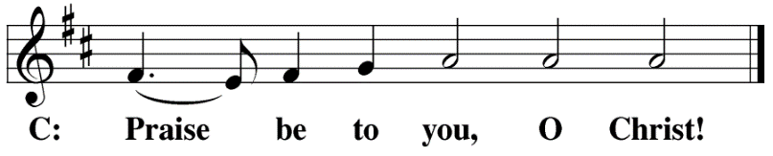

HYMN OF THE DAY Drawn to the Cross| CW 387
SERMON Romans 3
NICENE CREED
Having heard the Word of God, we confess our faith in His name. The creed is our saying back to God what He has first said to us. In the Creed we acclaim the truth of the triune God and His work of salvation accomplished for us in His incarnate Son, Jesus Christ.
We believe in one God, Dt. 6:4
the Father, the Almighty, 2 Cor. 6:18
maker of heaven and earth, Is. 51:13
The Nicene Creed is the great Confession of the Christian faith professed by all Christians. The Creed originated at the First Council of Nicaea (c. AD. 325)
of all that is, seen and unseen. Col. 1:16
We believe in one Lord, Jesus Christ, 1 Cor 8:6
the only Son of God, Jn. 3:16
eternally begotten of the Father, Heb. 1:2,5
God from God, Light from Light, true God from true God, Jn. 1
begotten, not made, of one being with the Father. Jn. 10:30
Through him all things were made. Jn. 1:3
For us and for our salvation, 1 Th. 5:9
he came down from heaven, Jn. 6:38
was incarnate of the Holy Spirit and the virgin Mary, Lk. 1:35
and became fully human. Gal. 4:4

For our sake he was crucified under Pontius Pilate. Mk. 15:15
He suffered death and was buried. 1 Cor. 15:3-4a
On the third day he rose again in accordance
The Creed itself was crafted as a confession of Scripture in opposition to the Arian heresy, which denied that the Lord Jesus and the Holy Spirit are God.

with the Scriptures. 1 Cor. 15:4b
He ascended into heaven Ac. 2:33-34
and is seated at the right hand of the Father. Heb. 1:13
He will come again in glory Mt. 25:31
to judge the living and the dead, 2 Tim. 4:1
and his kingdom will have no end. Lk. 1:33
We believe in the Holy Spirit, the Lord, the giver of life, Job 33:4
who proceeds from the Father and the Son, Jn. 15:26
who in unity with the Father and the Son Jn. 4:24
is worshiped and glorified,
who has spoken through the prophets. 2 Pet. 1:25
We believe in one holy Christian Mt. 16:18; Eph. 2:19-20
and apostolic Church.
We acknowledge one baptism for the forgiveness of sins. Eph. 4:5; Ac. 2:38
We look for the resurrection of the dead 1 Cor. 15:21-22
and the life of the world to come. Amen. Rev. 22

OFFERING
In response to God’s love and forgiveness, we give back a portion of what he has given us. The members of Christ Lutheran Church have joined to proclaim the gospel to this community. These offerings support that work. While our guests are welcome to participate, they should not feel obligated to do so.

PRAYER OF THE CHURCH
M: Heavenly Father, pour out Your Holy Spirit and write Your Word on our hearts, that we may know You as the God who forgives our iniquities and remembers our sins no more. Lord, in Your mercy,
C: Hear our prayer.
M: Heavenly Father, bless and sustain Mark, our Synod president; John, our district president; David, our circuit pastor; and all pastors. They like all people sin and fall short of your glory. Grant that they would deal with us gently, and keep them faithful to proclaim Your Word. Lord, in Your mercy,
C: Hear our prayer.
M: Heavenly Father, Your Son came not to be served but to serve. Help us not lord our authority over one another, but humbly serve one another in our homes, communities and congregation as Christ has so humbly served us. Lord, in Your mercy,
C: Hear our prayer.
M: Heavenly Father, look with mercy on all earthly authorities. Guard them from the temptation to wield earthly power improperly. Lead them to serve faithfully according to Your good and gracious will. Lord, in Your mercy,
C: Hear our prayer.
M: Heavenly Father, as Your only begotten Son learned obedience though what He suffered, we pray that You would instruct, bless and relieve Your servants who bear crosses of illness or pain. Sustain them as they walk the way of the cross with Your Son, that they may know the fullness of His eternal salvation.
Special intercessions may be included here
P: Lord, in Your mercy
C: Hear our prayer.
M: Heavenly Father, Your Son stands before You as our great High Priest. By Your Spirit, prepare our hearts to worthily receive the body and blood of our Savior, who was sacrificed for us on the cross for the forgiveness of our sins. Lord, in Your mercy,
C: Hear our prayer.
M: Into Your hands, O Lord, we commend all for whom we pray, trusting in Your mercy; through Jesus Christ, our Lord.
C: Amen.

LORD’S PRAYER Matthew 6:9-13; Luke 11:2-4
C: Our Father, who art in heaven,
hallowed be thy name,
thy kingdom come,
thy will be done on earth as it is in heaven.
Give us this day our daily bread;
and forgive us our trespasses,
as we forgive those
who trespass against us;
and lead us not into temptation,
but deliver us from evil.
For thine is the kingdom
and the power and the glory
forever and ever. Amen.

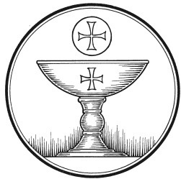
The Service of the Sacrament
This greeting marks a new service, so to speak. These ancient introductory words & phrases help to highlight, celebrate and bring attention to the Sacrament.
M: The Lord be with you.
C: And also with you.
M: Lift up your hearts.
C: We lift them up to the Lord.
M: Let us give thanks to the Lord our God.
C: It is right to give him thanks and praise.
M: Praise to the God and Father of our Lord Jesus Christ! In love he has blessed us with every spiritual blessing. He gave his Son to be the atoning sacrifice for our sins, and not only for ours but also for the sins of the whole world. Now have come the salvation and the power and the kingdom of our God and the authority of his Christ. To him who sits on the throne and to the Lamb be praise and thanks and honor and glory for ever and ever:

HOLY, HOLY, HOLY – Sanctus
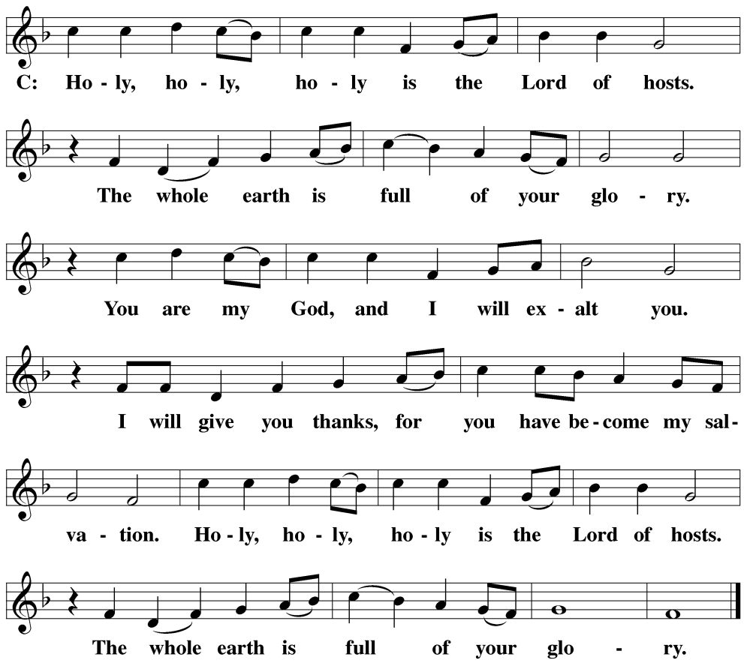
WORDS OF INSTITUTION Matthew 26, Mark 14, Luke 22
M: Our Lord Jesus Christ, on the night he was betrayed, took bread; and when he had given thanks, he broke it and gave it to his disciples, saying: “Take and eat. This is my ✙ body, which is given for you. Do this in remembrance of me.”
The Words of institution both proclaim the words of Jesus to the congregation and sets apart the bread and wine for the Lord’s Supper.
Then he took the cup, gave thanks, and gave it to them, saying, “Drink from it all of you; this is my ✙ blood of the new covenant, which is poured out for you for the forgiveness of sins. Do this, whenever you drink it, in remembrance of me.”
PEACE OF THE LORD – Pax Domini John 20:19
M: The peace of the Lord be with you always.
C: Amen

O CHRIST, LAMB OF GOD – Agnus Dei John 1:29
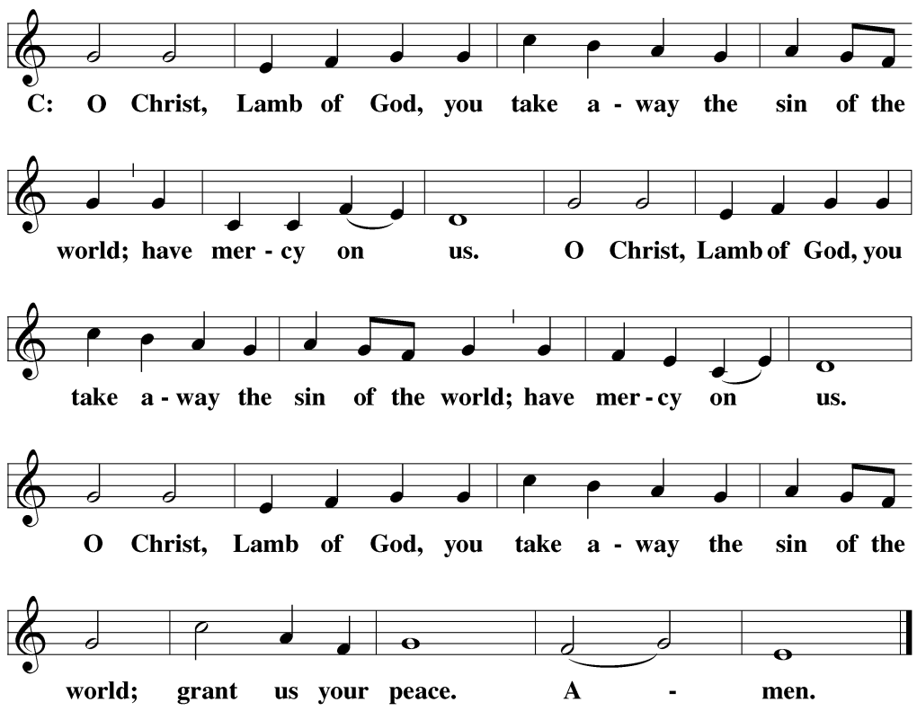
DISTRIBUTION
Those who will be receiving Holy Communion today may wish to read Personal Preparation for Holy Communion, found on page 156 in the front section of the hymnal. This page helps us put into practice what the Bible encourages: “Everyone ought to examine themselves before they eat of the bread and drink from the cup.” (1 Corinthians 11:28)
Christ Lutheran Church confesses and practices the Biblical teaching of a Closed Communion. We ask that only members of the Wisconsin Synod [WELS] or the Evangelical Lutheran Synod [ELS] join us at the Lord’s Table. If you have questions concerning our communion practice, or would like to inquire about how you, too, can commune with us, please speak with the Pastor following the service.

THANK THE LORD
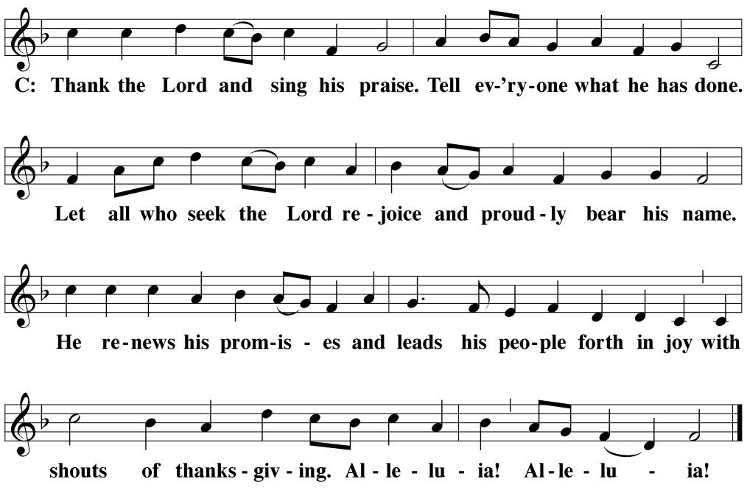
M: Hear the prayer of your people and accept our praises, O Lord God, heavenly Father. Since we have received Him today through his true Body and Blood, may Christ be our shield this day: Christ with us, Christ before us, Christ behind us. Christ above and below us; Christ to the right of us, and to our left. Christ in every mind that thinks of us, in every mouth that speaks of us, in every eye that sees us. And may the sound of our prayers become in your ear the voice of Christ, in whose name we pray.
C: Amen.

THE BLESSING
M: Brothers and sisters, go in peace. Live in harmony with one another. Serve the Lord with gladness.
The Lord bless you and keep you.
The Lord make his face shine on you and be gracious to you.
The Lord look on you with favor and ✙ give you peace.
C: Amen.
CLOSING HYMN Oh, That the Lord Would Guide My Ways| CW 462

COPYRIGHT INFORMATION
Content requiring a copyright license is reproduced under OneLicense.net #A-718312. All rights reserved. The Common Service: Texts revised from The Lutheran Hymnal, 1941. Music revised by James Engel. Scripture Quotations: From the Holy Bible, New International Version (NIV 1984), © 1973, 1978, 1984 by Biblica, Inc.

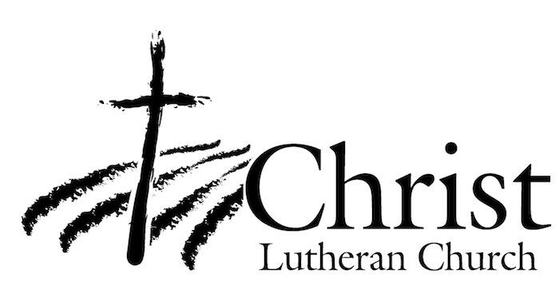
13009 N. Elderberry Ct.
Lodi, CA 95242
www.christlodi.org
209-368-6250
Pastor Timothy Leistekow
WELCOME TO CHRIST EV. LUTHERAN CHURCH!
We preach a message of forgiveness, hope and peace
through the death and resurrection of Jesus Christ.
Families and individuals of all ages will find opportunities
both to grow and to serve.
Our mission statement:
Look what Christ is doing!
He binds us together in fellowship
He gathers us in for worship
He builds us up for service
He sends us out with the gospel

“Now you are the body of Christ,
and each one of you is a part of it.”
(1 Corinthians 12:27)

